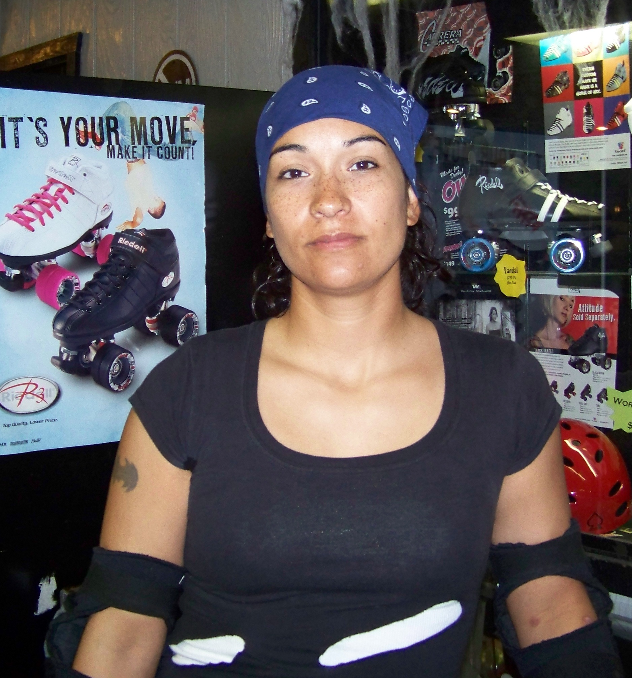
Leslie Bien
Name: Gina

Hometown: Dinuba-Visalia Favorite Color: Blue

Occupation: Bad Ass! Hobbies: Skating

If you could change one thing about yourself what would it be: I wish I could be more patient! Maybe with age I’ll learn how to be.

Is this your first time on a team: No, I played tons of sports throughout my school years. Wrestling being one of them. ☺

How long have you been doing derby: 2 Years

Why did you join the team: Something I hadn’t tried yet. Felt challenging and I’m always looking for any way to push myself and test my limits.

How did you get your name: It’s an inside joke. My husband came up with it. I have a “man” job with a “man” uniform. I have several lesbian friends that tell me I need to come out already. It was just a fun name!

What is your favorite position: I enjoy playing a Blocker!

Have you ever been badly injured: I have! I separated my shoulder. Basically I tore two tendons and my shoulder dropped so my collar bone sticks up permanently.

Do you have a favorite sports figure or someone you look up to: I love Gina Carrano! She is a MMA fighter and Mui Tai boxer. She F-ing rocks!

Anything you would like to add: Anyone thinking of finding something fun, challenging or just wants to be a part of a group of great women should come out for roller derby. V-Town Roller Derby!

